The Trinity Framework of Cognitive Systems
Unification -- Emergence -- Paradoxical Coherence
A Structured Critical Thinking Architecture for Adaptive Civilizations

1. Introduction
Modern civilization relies heavily on a cognitive framework that can be described as Analytical Differentiation (fen bie fa). This framework has enabled the development of modern science, engineering, governance systems, and technological civilization. It operates through four fundamental processes:
- classification
- boundary definition
- logical reasoning within categories
- structured problem decomposition
However, this same method often generates persistent conceptual conflicts, because it relies on rigid conceptual boundaries. Examples include:
- freedom vs. security
- equality vs. efficiency
- centralization vs. autonomy
- tradition vs. innovation
These oppositions are typically treated as mutually exclusive choices. In complex systems, however, such conflicts may arise not from reality itself but from the conceptual frameworks used to describe it.
To address these limitations, this paper proposes a multi-layer cognitive architecture called the Trinity Framework, organized into three functional layers:

Layer | Component | Function
Exploration Method | Impossible-First Reasoning | Identify hidden structural constraints
Core Cognitive Trinity | Unification | Structural insight
Core Cognitive Trinity | Emergence | Generative innovation
Core Cognitive Trinity | Paradoxical Coherence | Adaptive equilibrium
Operational Execution | ADPIE Decision Cycle | Implementation and evaluation

Together these mechanisms form a structured system for critical thinking, discovery, innovation, and implementation.

2. Impossible-First Reasoning

Exploratory Entry Method
Traditional reasoning begins with existing knowledge and attempts to derive solutions within known constraints. Impossible-First Reasoning begins in the opposite direction. Instead of starting with what is known to be possible, it begins by imagining scenarios that appear impossible under current understanding.
The purpose of this step is not to propose unrealistic solutions, but to reveal hidden structural assumptions and map the constraints that define impossibility within a given system.

2.1 Stage 1 -- Radical Imagination
The first stage deliberately explores ideas that appear impossible. These scenarios function as conceptual probes that expose the boundaries of current frameworks. At this stage the process is intentionally imaginative rather than analytical. Examples of such speculative questions include:
- How could a system manipulate the laws governing its environment?
- How could distributed microscopic agents collectively influence a global field?
- How could a system gain control over a structure by becoming part of it?

2.2 Stage 2 -- Constraint Identification
After the impossible scenario is imagined, the next step is to analyze why it appears impossible. Understanding these constraints reveals the structure that enforces the impossibility. Such constraints commonly include:
- symmetry conditions
- conservation laws
- equilibrium states
- rule-system definitions

2.3 Stage 3 -- Structural Reframing
Once the constraint is identified, the reasoning process explores whether the limitation arises from a particular conceptual framework. If the structure that produces the constraint can be reframed, the problem itself may change form. At this stage the reasoning process transitions naturally into the Unification Method, which identifies the deeper structures that generate conceptual oppositions.

2.4 Structural Approaches Revealed by Impossible-First Thinking
Several conceptual strategies frequently emerge during this process. These approaches connect directly to later components of the Trinity Framework.

Strategy | Description
Structural participation | A system gains influence by becoming part of the structure it interacts with
Rule-level interaction | System behavior changes through modification or interaction of governing rules
Distributed control | Many small agents collectively influence global behavior
Structural reframing | The conceptual framework producing the problem is redefined

3. The Unification Method (Gui Yi)
The Unification Method addresses conflicts created by analytical differentiation. Instead of resolving disputes within existing conceptual categories, the method examines the generative structures that produce those categories. Conflicts are resolved not through compromise, but through structural reframing.
The method operates through three sequential stages:

Stage | Chinese Term | Description
Structural Abstraction | San Yuan Gui Er | Multiple conceptual categories are reduced to underlying dynamic axes
Paradox Dissolution | Er Yuan Gui Yi | Opposing concepts are recognized as expressions of a shared structure
Boundary Dissolution | Yi Yuan Gui Dao | The conceptual framework producing the opposition is transcended

For example:
- freedom / security --> governance risk parameters
- centralization / autonomy --> coordination structures

4. The Non-Positional Center (Zhong Yong)
The Unification Method has philosophical precedents in several intellectual traditions. One particularly clear illustration appears in the Confucian concept of Zhong Yong (the non-positional center). Understanding this concept clarifies what the Unification Method implies about the nature of balance itself.
Many interpretations of balance assume a linear scale in which the middle represents a compromise between two extremes:

left -------------------- right
left ---- middle ---- right

However, this structure is inherently unstable because the scale has no fixed boundary. Positions may extend indefinitely, causing the midpoint to shift.

Confucian Interpretation
In the Confucian concept of Zhong Yong, the center is not located on the scale. It exists outside the oppositional structure:

left -------------------- right
|
center

The center does not balance the extremes. Instead, it changes the conditions that generate the opposition. The center thus represents a structural exit rather than a midpoint.

Relationship to Unification
This interpretation aligns directly with the Unification Method. Rather than choosing between opposing positions, the system identifies the generative structure producing the opposition. When the structure changes, the opposition itself may dissolve.

5. The Emergence Method (Yong Xian)
While Unification reveals underlying structures, the Emergence Method governs the generation of new structures through interaction. Rules function as reactive elements within a generative system -- a process that can be described metaphorically as rule chemistry.
Traditional systems operate according to a linear logic:

rules --> behavior --> outcomes

Emergence operates at a deeper level, where rules interact to produce new rule structures:

rule A + rule B + rule C
|
interaction
|
new rule structures

Because rule interactions involve nonlinear feedback, their outcomes cannot always be predicted. Instead of designing final outcomes directly, emergence focuses on creating environments where beneficial structures can arise. The framework therefore relies on the ADPIE evaluation stage to continuously test emergent structures against core objectives such as cooperation, stability, and long-term resilience.

Example: Emergent Complexity
In biological systems, simple local rules can produce complex global structures. Examples include:
- cellular growth patterns
- ant colony organization
- ecological systems

6. Paradoxical Coherence (Qi Gui)
When Unification and Emergence operate simultaneously, a distinctive systemic state may arise. This state is called Paradoxical Coherence. The system functions as a dual engine:

Unification --> identifies generative structures
Emergence --> generates new structures

Paradoxical Coherence does not imply logical contradiction. Instead, it describes systems in which multiple structural principles operate simultaneously at different levels. Systems in this state may appear contradictory to observers using traditional analytical frameworks; however, the apparent contradiction arises because multiple structural processes operate simultaneously.
Many natural and institutional systems exhibit this property. For example, light behaves as both a wave and a particle depending on experimental conditions, a phenomenon known as wave-particle duality. Similarly, stable governance systems often combine centralized coordination with decentralized autonomy, maintaining coherence through the simultaneous operation of both principles.

7. The Trinity Framework
The core of the framework consists of three cognitive engines, supported by an exploratory entry method and an operational execution cycle.

Mechanism | Layer | Function
Impossible-First Reasoning | Exploration | Identifies structural constraints and reveals hidden assumptions
Unification | Core Trinity | Structural insight through generative analysis
Emergence | Core Trinity | Generative innovation through rule interaction
Paradoxical Coherence | Core Trinity | Adaptive equilibrium during transformation
ADPIE | Execution | Operationalizes insights through structured decision cycles

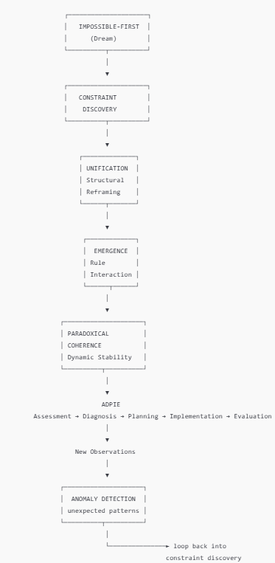
Figure 1. Architecture of the Structured Critical Thinking System. The Trinity (Unification--Emergence--Paradoxical Coherence) forms the core cognitive engine, supported by Impossible-First Reasoning as the exploratory entry point and ADPIE as the operational execution loop.

8. Operational Layer: ADPIE
Conceptual insight alone is insufficient for real-world decision-making. Practical systems require structured operational processes. Within the Trinity Framework, ADPIE functions as the execution cycle that operationalizes the conceptual insights generated by the three cognitive engines.

Stage | Function
Assessment | Gather relevant information about the problem context
Diagnosis | Identify the underlying problem or structural constraint
Planning | Design possible interventions or structural modifications
Implementation | Execute the chosen actions
Evaluation | Measure results and adjust strategy accordingly

ADPIE operates at multiple scales simultaneously. Rapid micro-cycles occur in local decision contexts, while slower macro-cycles guide long-term institutional evolution.

ADPIE as Stability Mechanism
The Evaluation stage acts as a stabilizing feedback loop. While emergence allows new rule structures to appear, evaluation ensures these structures remain aligned with core system objectives such as cooperation, systemic stability, and long-term survival. Adaptive evolution therefore remains bounded by feedback rather than drifting into chaos.

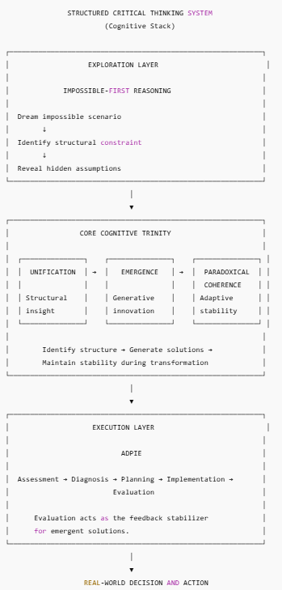
Figure 2. Cognitive Flow of the System. The reasoning process begins with radical imagination through Impossible-First Reasoning, which reveals structural constraints. These are reframed through Unification, new possibilities generated through Emergence, stability maintained through Paradoxical Coherence, and insights implemented through ADPIE.

9. Structured Critical Thinking
The combined framework can be understood as a system of Structured Critical Thinking. Each component performs a distinct cognitive function within the reasoning process.

Cognitive Function | Method
Exploration | Impossible-First Reasoning
Structural analysis | Unification Method
Innovation | Emergence
Stability | Paradoxical Coherence
Execution | ADPIE

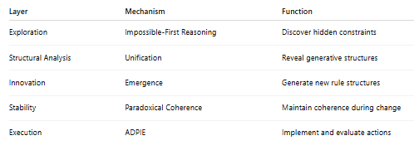
Figure 3. Functional Roles of Each Component. Each mechanism performs a distinct cognitive function: Impossible-First Reasoning explores conceptual boundaries, the Trinity engines provide structural insight and generative innovation, and ADPIE implements and evaluates real-world actions.

10. Civilizational Implications
In complex societies, many conflicts arise from differences in values rather than material scarcity. As technological development reduces scarcity through automation, artificial intelligence, and advanced manufacturing, such value-based conflicts may become increasingly central to civilizational governance.
The Trinity Framework offers a cognitive architecture capable of addressing these challenges by allowing:
- structural reframing of ideological conflicts
- emergence of new institutional models
- adaptive stability during systemic change
Within the System of Eternity (SOE) architecture, governance becomes a continuous process of experimentation and renewal rather than a fixed institutional design. The Trinity Framework provides the cognitive infrastructure through which such adaptive governance can be sustained.

11. Conclusion
This paper proposes a multi-layer cognitive architecture integrating exploration, structural insight, generative innovation, adaptive stability, and operational execution. The framework combines five complementary mechanisms:

Mechanism | Role
Impossible-First Reasoning | Exploratory discovery
Unification | Structural understanding
Emergence | Generative innovation
Paradoxical Coherence | Adaptive stability
ADPIE | Practical execution

Individually, each component of the framework already exists in various disciplines. Analytical reasoning, emergence theory, feedback loops, and philosophical traditions of balance have long been studied independently.
What the Trinity Framework provides is an integrated architecture that connects exploration, structural insight, generative innovation, adaptive stability, and operational execution into a single cognitive system. This integration enables complex systems -- whether scientific, institutional, or civilizational -- to evolve continuously while maintaining coherence.

